“The Original”  REDLINE WEBER K551 | 

Conversion for Jeep 258

W/2bbl Carter BBD 78 on
Redline offers a complete range of applications as a direct replacement. All carburetors offer full scale driveability for performance, economy or off road rock climbing.
Redline Weber adds horsepower and torque.

Full range of conversions with Manual choke or easy start auto choke.

K551M - K551 - K551 38 THE REAL DEAL !!!!!

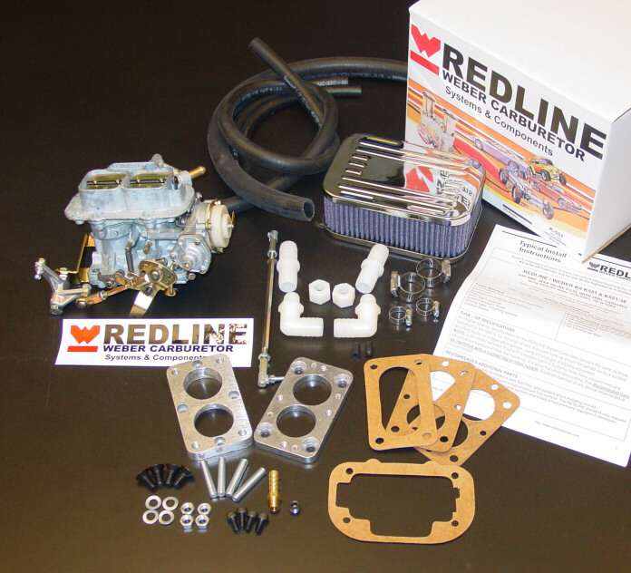

The Original Redline Weber conversion kits use ONLY original Weber carburetors.

Do not settle for Alternatives, Replacements or Solex carburetors disguised as Weber.

Redline developed the first Jeep conversion, no other matches our quality and direct bolt on functionality under all driving conditions. Redline Weber’s experience in developing quality, performance driven kits is second to no one. Others have attempted to copy our product and complete package but none equal our value, performance and technical support.

REDLINE has conversion packages for the complete range of Jeep Applications
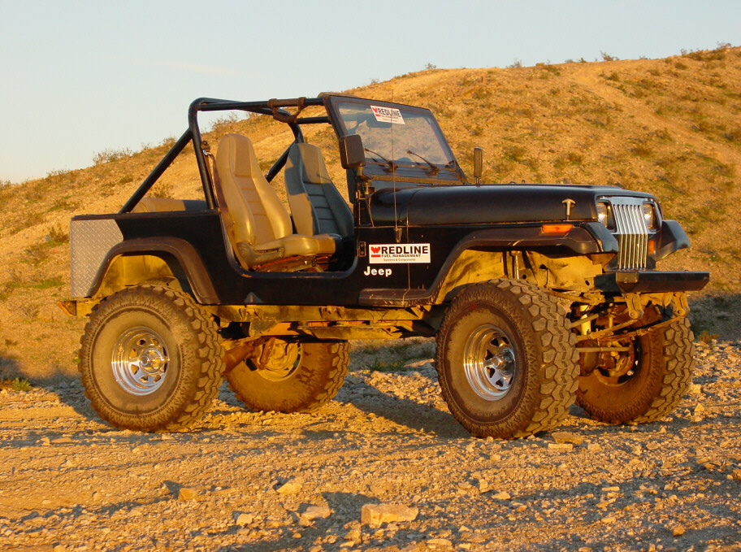
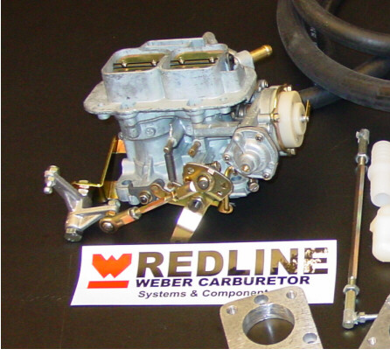
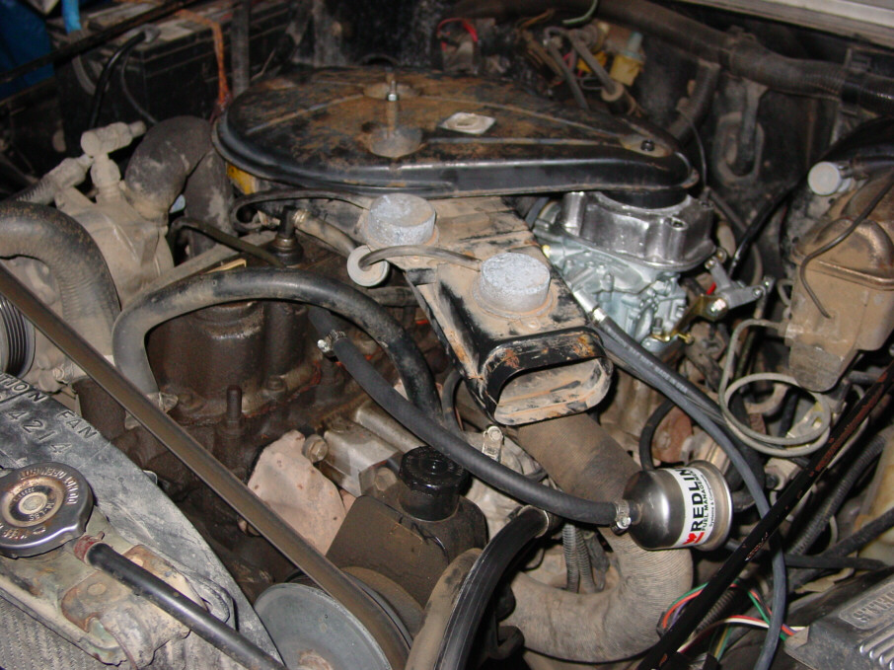
Using the progressive 32 36 DGV manual choke carburetor

Redline offers the ALL NEW K551 M
The manual choke conversion offers simple, reliable function to keep the cost down.

Features a manual choke for simplicity,
Flexibility and convenience.
Available accessories and air filter adapters to maintain OEM filter conversion, or high flow washable filters to improve air flow and filtration quality.
A full range of accessories to upgrade your conversion

There are cheaper conversions but only Redline Weber gets it right the first time every time.
Be confident, Redline Weber is the real deal.

Conversion kits from mild to wild. 32/ 36 DGEV progressive to the “Outlaw” 38 DGAS
ONLY Genuine WEBER CARBURETORS

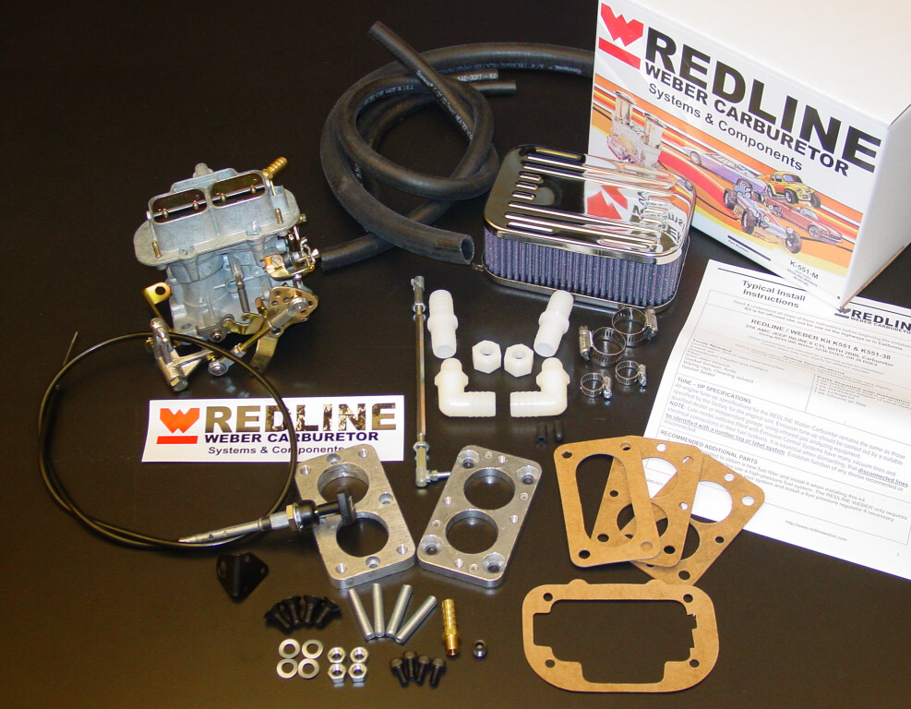
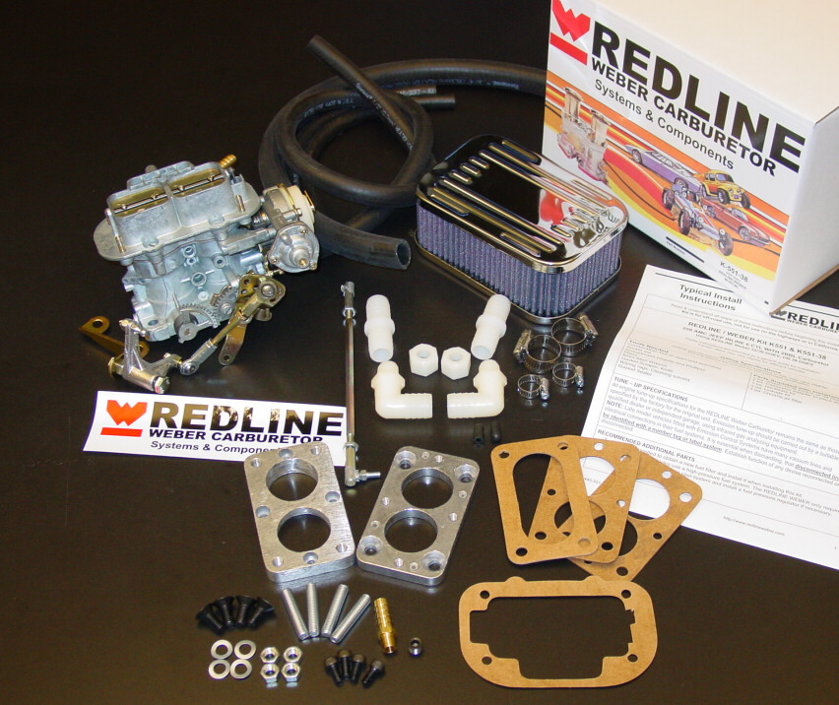
K551 M 32 36 DGV Manual choke conversions, Original Weber
Kits come complete with base calibration set up for street or trail use.

Kit also includes choke cable and dash mount for easy installation.

Available accessories include
Jet pac for ideal calibration for fuel changes or Altitude variation
10 high flow washable full breather super flow filters.
Air filter adapter kit to help maintain the OEM air filter and emissions system set up.

REDLINE leads the industry in off-road Jeep carburetor conversions. This new kit is ready for any driving situation and condition.
K551 32 36 DGEV progressive Electric choke, Original Weber

The Original reliable Weber auto choke unit for quicker starting and faster warm up. Improved fuel economy, and replacement performance. The best compromise of performance and economy.

I deal for keeping the OEM choke function for cold start drivability and easy start ups in all weather.

Available accessories include
Jet pac for ideal calibration for fuel changes or Altitude variation
10 high flow washable full breather super flow filters.
Air filter adapter kit to help maintain the OEM air filter and emissions system set up.

K5551 38 38 DGES Total Performance with Electric choke, original
Weber

This kit is the total performance package.

Best torque for real jeep off road action, no lose of fuel economy like when it was new
The absolute best package for the real trail jeep with lift and large tires the torque and hp to handle any situation and any hill or climb,

The complete range of accessories and upgrades
Each kit is calibrated to work out of the box

